SPASMODIC COLIC
Etiology
- Occurs sporadically.
- Include excitement, such as occurs during thunderstorms, preparations for showing or racing, and drinks of cold water when hot and sweating after work.
- Presence of a heavy burden of tapeworms (Strongylus vulgaris larvae)
- Psychogenic colic occurs rarely in horses.
Epidemiology
It affects horses of all ages but is not recognized in young foals. No apparent breed or sex predisposition is noted.
Pathogenesis:
Mucosal penetration and submucosal migration of Strongylus vulgaris larvae are known to cause changes in ileal myoelectrical activity that could lead to the development of colic in horses. The hypermotility of spasmodic colic in horses is thought to arise by an increase in parasympathetic tone under the influence of the causative factors mentioned above.
CLINICAL FINDINGS
- Brief attacks of abdominal pain, and the pain is intermittent.
- The horse are rolling, pawing and kicking for a few minutes.
- Shaking itself and standing normally for a few minutes until the next bout of pain occurs.
- Intestinal sounds are often audible some distance from the horse and loud,
- On auscultation are heard rumbling borborygmi sound.
- The pulse is elevated moderately to about 60/min.
- patchy sweating, but rectal findings are negative and there is no diarrhea.
- Rectal examination is usually unremarkable. The signs usually disappear spontaneously within a few hours.
Clinical pathology
Laboratory examinations are not used
Treatment:
- Antispasmodic drug .
- Analgesic

SAN D COLIC
Sand colic is a disease of horses grazing sandy fields with short pasture. Etiology:
- Fed on sandy ground.
- Provided with feed contaminated with sand.
- Underfeeding.
Epidemiology:
Horses of all ages are affected, including foals, which acquire the sand while eating dirt. The case fatality rate for horses treated by surgical removal of sand is 20-40%.
Pathogenesis:
The disease is attributable to sand accumulation in the right dorsal or transverse colon, or pelvic flexure, causing obstruction. Sand in the ventral colon does not cause obstruction but is associated with colon volvulus and displacement.
Clinical signs:
- Mild to moderate, the colic is very mild unless there is colon torsion or volvulus (typical sign).
- The diarrhea is watery but not profuse or malodorous.
- Auscultation over the cranial ventral abdomen just caudal to the xiphoid reveals sounds similar to those made when a paper bag is partially filled with sand and rotated. This sound is diagnostic of sand accumulation in the ventral colon.
- Rectal palpation may reveal sand impaction in the ventral colon, but more frequently colon distension with gas is present.
- Rectal palpation will not detect sand accumulation in the transverse colon.
Clinical pathology:
- Radiography will demonstrate sand in the ventral and dorsal colons and can be used to monitor the efficacy of treatment.
- Ultrasonography has good sensitivity (88%) and specificity (88%) compared to radiography for detection of sand in the ventral colon. and is not as effective at detecting sand in the right dorsal or transverse colon.
- Abdominal fluid is normal except when there is ischemia or necrosis of the colon or when peritonitis is present.
- Fecal sample then the feces is mixed with water in a clear plastic rectal sleeve and hung for 30 minutes then the Sand will settle out .

Treatment:
Medical treatment. In less acute cases,
- pain relief and correction of fluid and electrolyte abnormalities.
- Administration of psyllium mucilloid (0.5-1 g/kg orally every 12 h for 4-8 weeks) administered via a nasogastric tube or as a dressing on feed.
- Mineral oil (1mL/kg) or MgS04 (1g/kg) orally may hasten sand removal.
Surgical treatment . In horses with acute obstruction of the right dorsal or transverse colon
- Removal of the sand.
Control of the disease
- Preventing ingestion of sand by feeding horses hay and grain from clean feeding bins.
- Providing adequate roughage in the diet.
- Pasturing horses in fields with adequate grass cover.
- Daily administration of psyllium mucilloid.
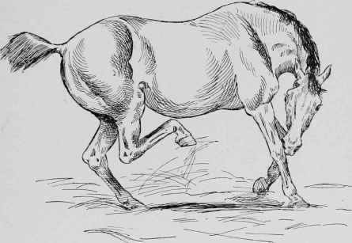
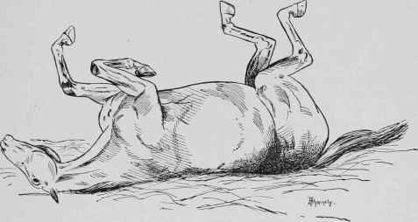
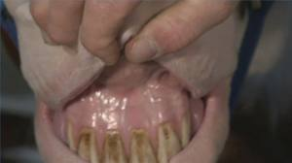
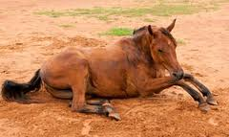
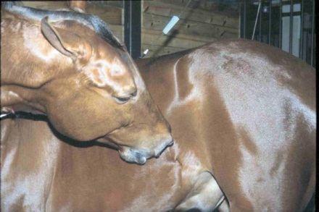
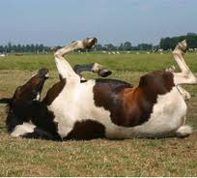
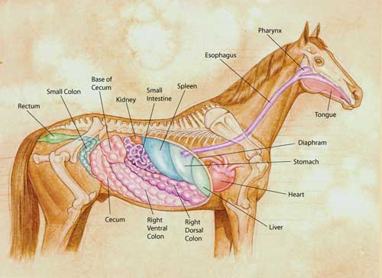
Digestive system

